TASK 6:

**-- Task 6: Web Scraping & Job Data Analysis**

**-- 1. Static HTML Page**

<html>

<body>

<div class="job-listing">

  <h2 class="title">Python Developer</h2>

  <span class="company">Tech Solutions</span>

  <span class="location">Karachi</span>

  <div class="skills">Python, Django, REST APIs</div>

</div>

<div class="job-listing">

  <h2 class="title">Data Analyst</h2>

  <span class="company">Data Minds</span>

  <span class="location">Lahore</span>

  <div class="skills">SQL, Excel, Power BI</div>

</div>

<div class="job-listing">

  <h2 class="title">Machine Learning Engineer</h2>

  <span class="company">ML Labs</span>

  <span class="location">Islamabad</span>

  <div class="skills">Python, Scikit-learn, Pandas</div>

</div>

</body>

</html>

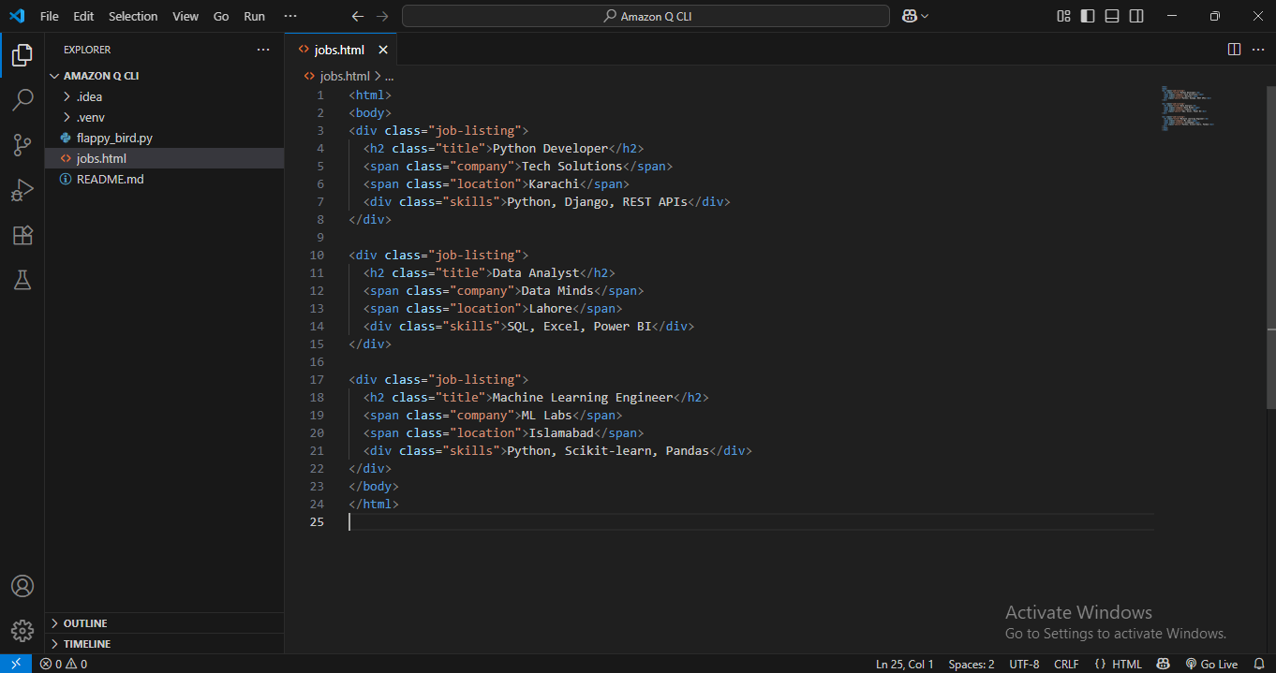

**-- 2. Python Code Snippet:**

**Parsing Job Listings**

jobs = soup.find_all("div", class_="job-listing")

**Extracting Fields**

title = job.find("h2", class_="title").text.strip()

**Saving to DataFrame**

df = pd.DataFrame(data, columns=["Job Title", "Company", "Location", "Skills"])

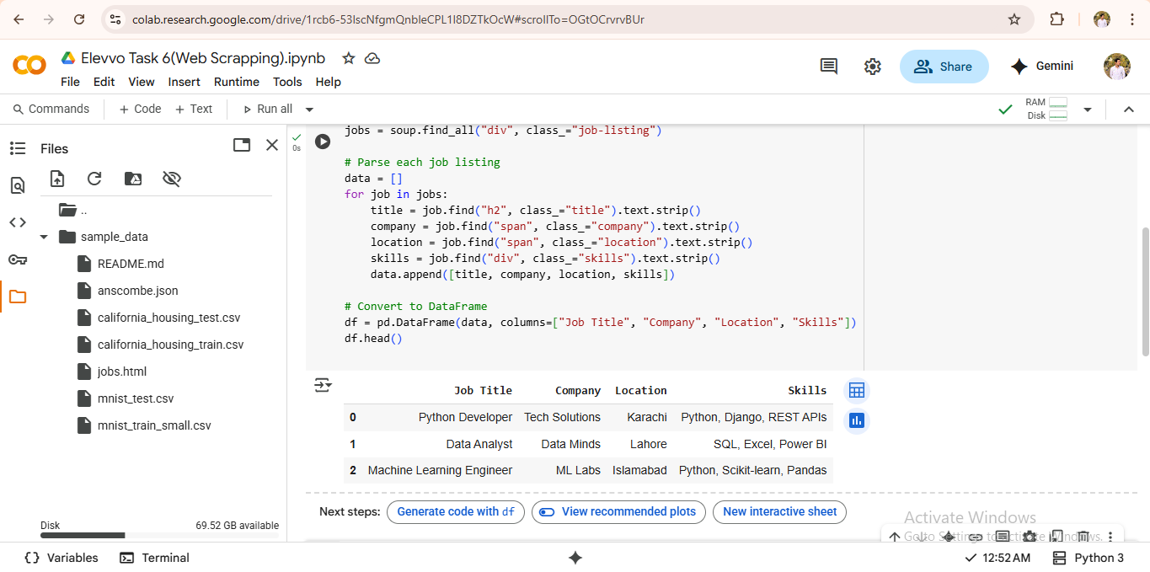

**-- 3. In-demand Skills:**

from collections import Counter

all_skills = []

for skills in df["Skills"]:

    all_skills.extend([s.strip() for s in skills.split(",")])

top_skills = Counter(all_skills).most_common(5)

print("Top 5 In-Demand Skills:", top_skills)

